

To: Ms. Samantha Pumar/Mr. Jestonie Donaire
WSI

From: Jack Roman Sangalang / Branch Supervisor Atc Branch
Date: November 19, 2025
Re: Defective HP Smart Tank 520

I Jack Roman T. Sangalang making this letter to report while we were organizing the stock room to prepare for the upcoming annual physical inventory, we found a defective hp printer in the stocks, we tried to test it but the printer head showed a error and there was spilled ink inside. It seems like it has bend stored for a long time because when I transferred here at atc branch last april 1, 2025 this is the only time we’ve seen it.

Seial Number: TH4252W09M

Thank You for your understanding for this Matter,
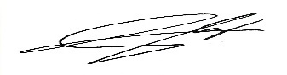

JACK ROMAN T. SANGALANG
Branch Supervisor

